**AbSolitude Game Design Document**

**Project’s GitHub page**

<https://github.com/Arthur-Kenichi-Condino/AbSolitude>

**License for the AbSolitude project (“O Saneador” game):**

The updated license can be found at the project’s GitHub page (<https://github.com/Arthur-Kenichi-Condino/AbSolitude/blob/main/README.md>).

**Credits**

Document written by:

Arthur Kenichi Condino Odaguiri (game creator)

Dárcio (preparando para Wiki)

https://github.com/Arthur-Kenichi-Condino/AbSolitude/tree/sistemaDeAIComCombate/docs/WikiContent

**Concept**

Mature game; for adults only: will contain nudity and sex scenes.

Comfortable game where you can creatively edit your terrain and place structures and objects, and then add or invite NPCs controlled by AI to live and interact with what you create.

These NPCs can follow or interact with your character, and protect it, or you can even turn aggressive and attack them.

The game has a relaxing vibe as you can play Third Person for more interactions but you also can leave your own character being controlled by AI and relax watching the actions it does by itself.

Main features:

* Comfort: leave your character be and go do other stuff in real life; and then come back later to see what happened;
* The Homunculus System: this may be actually the main feature of the game: creatures that act as “pets” which follow the player and are controlled by the game’s Artificial Intelligence system, and have main characteristics based on their type and attributes or skills, added for each time they level up;
* When multiplayer is added:

1. focus on chatting and relaxation: chat with other players while sitting by a fireplace in a cozy tavern; go into adventures through the world and, when it’s night, stop to cook some food and relax by a campfire;
2. homunculus system: you can sit still and relax talking to friends in the middle of a dangerous dungeon or map section: your (controlled by AI) homunculi will be there to protect you and keep you safe!
3. “squad system”:

**Stakeholder Analysis**

**The sponsor**

I, Arthur, am creating this game from scratch; I had started in Microsoft’s XNA framework, but then migrated to Unity as XNA wasn’t going to be updated anymore. I’ve been coding it for a long time and it has passed through many versions. My main development achievement for now is doing a system that uses multithreading as safely as possible, eliminating race conditions and deadlocks.

**Why did I choose Unity (and not Unreal)**

1. Unity is faster to learn and has less complex systems for manipulating objects and putting them into the scene ready to use your script;
2. Unity uses C#, my main language;
3. Unreal uses C++ and their asset management system isn’t so flexible: for example, if you name something wrong you’ll have a hard time changing it to a new name.
4. C++ isn’t as flexible as C# in my opinion (as it requires a correct order for the functions and every file needs its header, and headers must be requested in the right order for other files)

**The team**

As this project may generate revenue later, but it has not a defined date for the prototype or the launch build to be finished, the team is being recruited as if doing a “hobby project”: we work on this in our free time, with no requirement to dedicate full time on it.

If a revenue is generated, the values will be shared based on how much you helped and how much you added to the project as for number or complexity of the assets added.

The team may be small at first, for around at maximum 4 people for each subject (art, sound, coding, etc.). If we move to be a bigger team, we may need more people to help manage the roles and the goals for each one; so we can’t have it too big for now.

**Game Vision**

**Quick game vision description**

Randomly generated sandbox/editable world with homunculus system and combat system, which is based on attributes and skills, that has AI controlling the characters, then letting the main game focus on it being relaxing for the players; but containing stories and quests focused on ethical dilemmas.

**Game’s context**

The game’s story is a fictional future of the world, about some hundreds of thousands of years after our current real time, where science advanced so much that cloning and DNA modification was made to the point doppelgangers and new creatures called “homunculus” were generated.

At the same time, nature itself has changed and some animal species evolved resulting in new rational creatures with anthropomorphic appearance.

These creatures now have different types of relations and opinions on how to relate with humans, as in the past, they were just created to be eaten, like cows, pigs and chicken. Differently, cats’ and dogs’ “evolutions” also have different opinions, because they were pets or companions in the past.

Even after science has evolved so much in this new future, because of human’s greed and also because of its inconsequential and conflictual behavior, the resulting world is still not actually cleaner, healthier and not even greener; it’s now very polluted, harsh and divided. It’s not apocalyptical nor decaying but it’s not harmonious or easier to live with. It is just changed.

**Why are we creating this game?**

This project’s purposes are:

1. to create a “game engine” that can be used mainly to create this game and then be used in other games; the engine’s main functions are:
2. to create an automatically generated virtual world in which players can edit, build and interact and so to play the game in their own ways. This may be also called a “sandbox”;
3. to create a combat system that can work in first person, third person or from the free camera movement interactions;
4. to create an “Homunculus System”;
5. to create NPCs controlled by AI who interact with the player’s character and buildings;
6. to create special premade NPC characters that interact with the player in this virtual world, who have specific strong personalities;
7. to create a dynamic quest system linked to those NPCs;
8. to create stories in these quests in which the player has to deal with ethical dilemmas and discover ways to deal with them.

From what is written above and the information that can be found in the Game Design Document, the objectives of finishing this game project are to complete the main game which is continuously updated and is sold with available DLCs and microtransactions so we can earn some revenue to keep adding more content and to have a “game engine” from which other games can be created and that can be sold as an asset in Unity Store.

This game’s purpose is also to have its code open so it can be used in education activities: I, Arthur, believe it’s important to always share technology to help everyone have access to it: so to be able to learn and create their own content faster and more easily.

**How to earn revenue?**

To earn revenue, the main feature will be the microtransaction system of items that can help finish game interactions faster (examples: earning Experience faster, generate faster production from a Farm, acquire resources more easily from chopping down a Tree, etc.); and of visual items like clothes, hairstyles, visual effects and other cosmetics in general.

**What is the game story about?**

As for stories, they can be told in quests; the main objective in those though is to have the player be forced to deal with ethical dilemmas: questions which don’t have a fully right or wrong answer.

The player’s virtual world is populated with NPCs which have personalities that may generate conflicts: it depends on the player’s choices to solve them.

And it’s important to create a story which involves the player dealing with its “microsociety” having to interact with other randomly generated microsocieties in the world, with their own “culture” conflicts. This may put the player in the middle of questioning its own beliefs of right and wrong.

But the main story is not defined yet.

Some ideas I had were about a fictional future version of Earth that has genetically modified creatures, and also more species developed rational intelligence, giving them a humanoid appearance and intellect. So there could be some anthropomorphic creatures based on cows, dogs, cats, etc. as if they “evolved” from the animals we know today in reality.

Some of them could be at war with humans because of bad treatment they got in all the “old ages” before they were able to think in a more logical way.

**How many games do we require to tell this story?**

To be added.

**Idea Bucket**

New ideas this game introduce:

1. “Homunculus System”: characters controlled by AI that follow a player or a NPC and work as a squad defending it: they have their skills tree and attributes that can be selected by the player so each one will be unique; and their attributes are boosted or reduced depending on the player’s or the NPC’s attributes and skills they are following;
2. combat that can work from first person view, third person view or free camera view, also with squad system or controlled by AI, which helps the game to be more relaxing;
3. randomly generated editable world; the player creates a microsociety populated by NPCs controlled by AI, so the game can be really relaxing;
4. combat skills based on music (battle songs, songs that cause positive or negative effects on other characters).
5. non-limited skill tree and attributes choices: you can have any skill combined with any attributes you want for your character.

**What is already out there?**

“Homunculus System”: the idea comes from the game Ragnarök Online’s homunculus system. But I believe it wasn’t fully explored there and the game removed a lot of gameplay mechanics and abilities from it with the passing time; their system is a skeleton from which I want to use as a base to create a new one. Their homunculus system actually became a “pet system” in the end.

Randomly generated editable world: there are a lot of games with editable terrain already, but usually they use a height map terrain which doesn’t allow creating caves. This project uses a voxel system with smoothed terrain so any “holes” can be created while also allowing terrain volume placed on top of them.

**Similar Games**

Below, some reference games that have the “energy” the game should bring to the player.

**Ragnarök Online (Lee Myung Jin and Gravity Corp, August 31st, 2002)**

What’s in Ragnarök that it’s the first reference game:

1. the game gives you the experience to travel with friends, to play and party to kill the called “MVPs”*, to be part of a group and kill some monsters and share the Level Experience, and then go to the city and sit by the entrance to talk for hours;
2. the main homunculus system is featured in this game: you just sit there and open your chat to talk; and the homunculus does all the hard work for you! You just needed to program its AI beforehand though.

*main bosses, they got this name because they give a MVP emote to the player which did most of the damage

Original art by Lee Myung Jin:

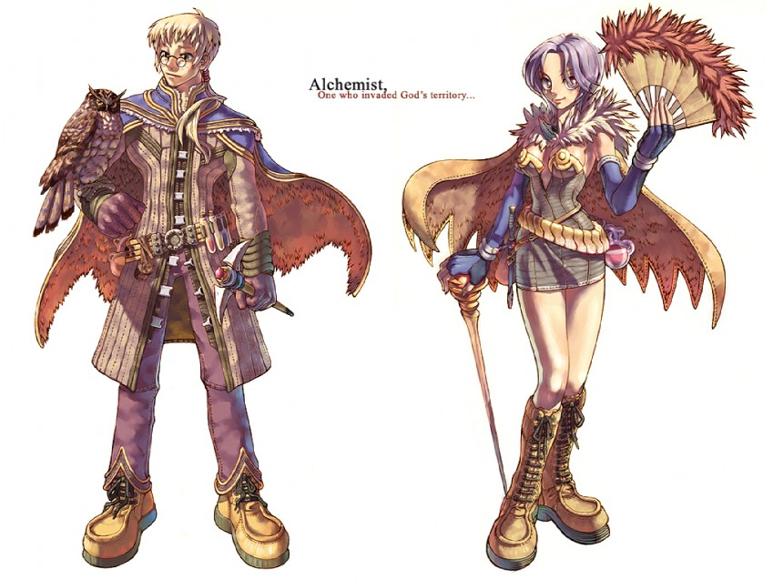

“Alchemist, One who invaded God’s territory…”, by Lee Myung Jin, Ragnarök Online

The alchemists in Ragnarök Online are the creators of the homunculi, it’s the class the player can choose to have their “pets” following them.

Actually, the game gives relaxing vibes because of the pets: you don’t need to worry about monsters or enemies, you can sit and let the homunculus do all the work.

Ragnarök Online is cozy, friendly. You don’t need to stay crazy focused all the time and stay actually “tired” when you finish playing.

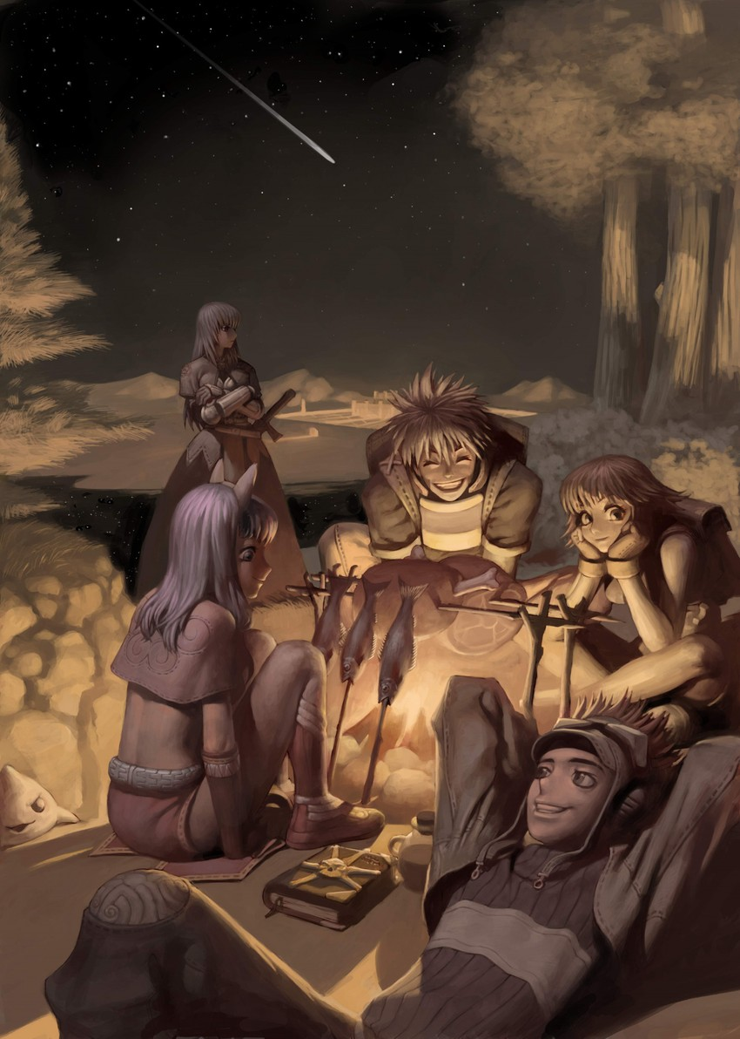

“Mage, Swordsman, Novice and Thief”, by Lee Myung Jin, Ragnarök Online

Something that the game could have adopted is allowing the called “Bots”, player characters controlled by software: they were not permitted; but having your player doing your work while you just stay calmly watching until you actually want to take control is also all about the relaxation I want to bring to my game.

**Main Gameplay Loop**

The game consists in:

1. Creating or selecting your character that can be used in multiple game worlds (you can export or import characters created in each game world);
2. Setting up the Voxel Terrain Generator for this gameplay;
3. [When multiplayer is added:] setting up server or host settings;
4. The terrain is generated! Now there are three main game modes:
5. *Interact Mode*: interact with objects placed in the world and give commands to simulation actors.
6. *Build Buy Edit Mode*: move or place objects in the world: floors, walls, doors, tables, chairs or whole buildings “rabbit holes”, plan a building so characters in the world can add the required material and finish the construction.
7. *Third Person Camera*: select a character with right mouse click and select on the context menu to set it to be the active object, then press the keyboard command and control the character from a third person camera.

**Interact Mode**

This mode allows the player to give commands to the creatures it selects with the mouse pointer.

**Build Buy Edit Mode**

In this mode, the player can move objects in the world and edit the terrain.

**Third Person Camera**

The player can come to this mode from Interact Mode and go back to normal Interact Mode later. It’s called Third Person Camera because it gives total control to the player over a character (move, jump, etc.) directly with the camera following it.

Zooming the camera can toggle it to change to First Person Mode.

**Mechanics**

To be added

**Homunculus System**

Homunculi are one of the main features of the game. They are creatures that follow their creator and help and protect them. They are controlled by the game itself using an AI, and by the player, so they enter in combat automatically or use skills when they are needed.

“Homunculus” is present in cartoons and some games nowadays, but it’s actually a term found in “alchemy”, preformationism and also folklore. It’s a fictional miniature human-like being.

The definition of homunculus can vary and I found some below, but in the game’s fictional context they are just “humanoid clones” from “human DNA” with “modifications”, and these modified clones resulted in generating these diverse creatures with different appearances and set of attributes and skills: the homunculi.

It’s a “man-made man [that] is formed alchemically—in a test tube—from human sperm, heated by horse dung for the forty weeks of normal human pregnancy, and ‘from such Artificial men, when they come to Man's age, are made Pygmies, Giants, and other great and monstrous men, who are the instruments of great matters’ [...]”, from

<https://arcade.stanford.edu/rofl/artificial-men-alchemy-transubstantiation-and-homunculus>: in this article, there are some definitions of homunculus, alchemy, and some of their implications in history.

The definition for the word “homunculus” is of a “little man”. “An early use of the word was in the 1572 work by Paracelsus regarding forays into alchemy, *De Natura Rerum*, in which he gave instructions on how to create an infant human without fertilization or gestation in the womb. In the history of embryology, the homunculus was part of the Enlightenment-era theory of generation called preformationism. The homunculus was the fully formed individual that existed within the germ cell of one of its parents prior to fertilization and would grow in size during gestation until ready to be born.”, from <https://embryo.asu.edu/pages/homunculus>.

[To do: research more info to describe the character origins better]

In the game, homunculi will have a more “friendly” approach, as a common character that can be summoned and actually may look and act like a pet for the player.

The main homunculi are going to be:

1. Vanilmirth

**Vanilmirth Concept**

The Vanilmirth homunculus type is based on the homunculus of the same name present on the game Ragnarök Online.



Original *Vanilmirth* in Ragnarök Online, unknown artist

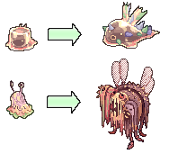

*Vanilmirth* sprites as seen in the game, Ragnarök Online, unknown artist, from <https://browiki.org/wiki/Vanilmirth>

Our remake of the Vanilmirth will still be friendly but more connected to the idea of a “failed” homunculus. As the original, the remake will remain as a clumsy homunculus that can randomly use the wrong skill for the moment, putting its owner in a bad situation during a combat; but also, with the same approach, it can turn the tides so the owner may find him or herself in a whole new better cenario. This homunculus is all about being “random”.

Key homunculus skills (no skill is constrained by homunculus type or character class, but the skills originally defined for this homunculus and that will be always present in it are):

***Caprice***

Ragnarök Online skill reference icon: 

The homunculus will use a random skill, from the entire game, in any level, limited only by the level of Caprice itself.

The skill can target any active character in the game, including the player’s character, the homunculus itself or enemies, so it’s a very powerful but also very dangerous skill. It’s a skill that gambles with the player’s luck.

For the technical implementation of this skill: currently, the skills are GameObjects in Unity that are being instantiated with the character that owns it, so it’s a clone of the skill Prefab: maybe it’ll not be possible to instantiate all skills for every Vanilmirth, or a pool can be used because instantiating and destroying stuff in Unity is very memory expensive.

***Change of Plans***

Change of plans is a passive skill that allows the homunculus to gain some attribute points. Whenever the skill is leveled up, the homunculus will gain a random range of attributes (Stamina points, Focus points, combat Defense points, Attack points, etc.), randomly selected and saved with the homunculus data.

In the same way, the homunculus will lose some attribute points, mirrored to the ones it gains: for example, if it gains Attack, it may lose Defense.

***Chaotic Blessing***

Ragnarök Online skill reference icon: 

When the skill is activated, the Vanilmirth homunculus temporarily adds and also removes random attributes from itself, a random foe and the owner. The homunculus will also Heal the owner, a random foe and itself in a random amount of Stamina points for each. When the skill timeouts, the attributes will go back to normal.

Who is considered a “random foe”: when in combat, one of the characters that may be attacking the owner or the homunculus; when out of combat: any aggressive possible target for the combat system currently active in the world.

**Vanilmirth Concept Art**

These are the first concept art files, created by Daniel Lucas:

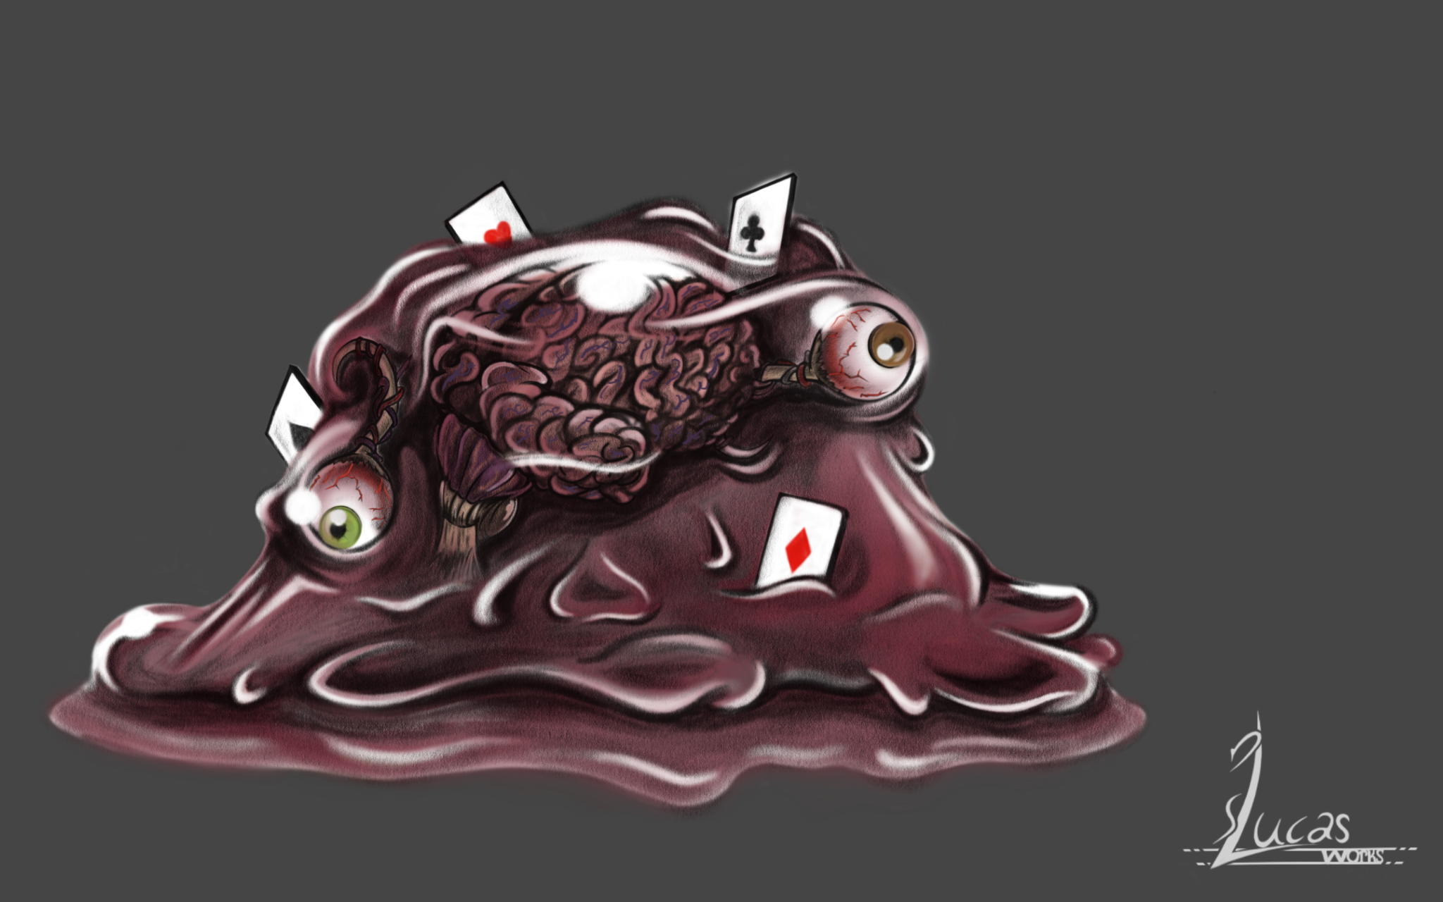

Homunculus *Vanilmirth* remake views for 3D modeling, by Daniel Lucas

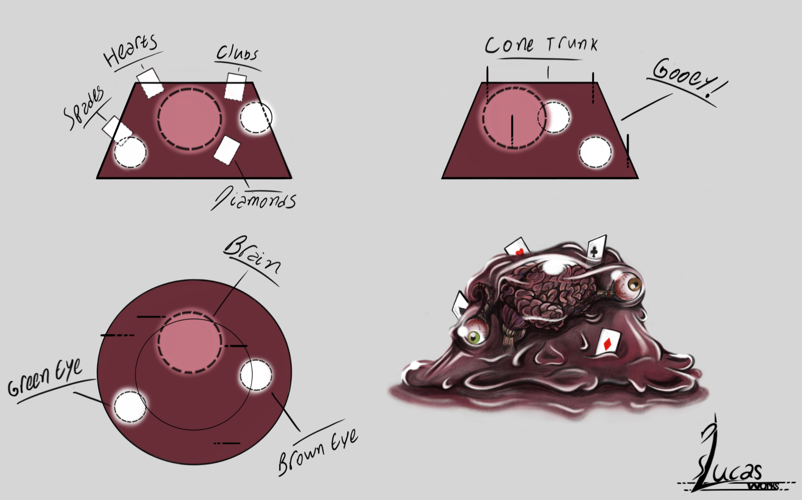

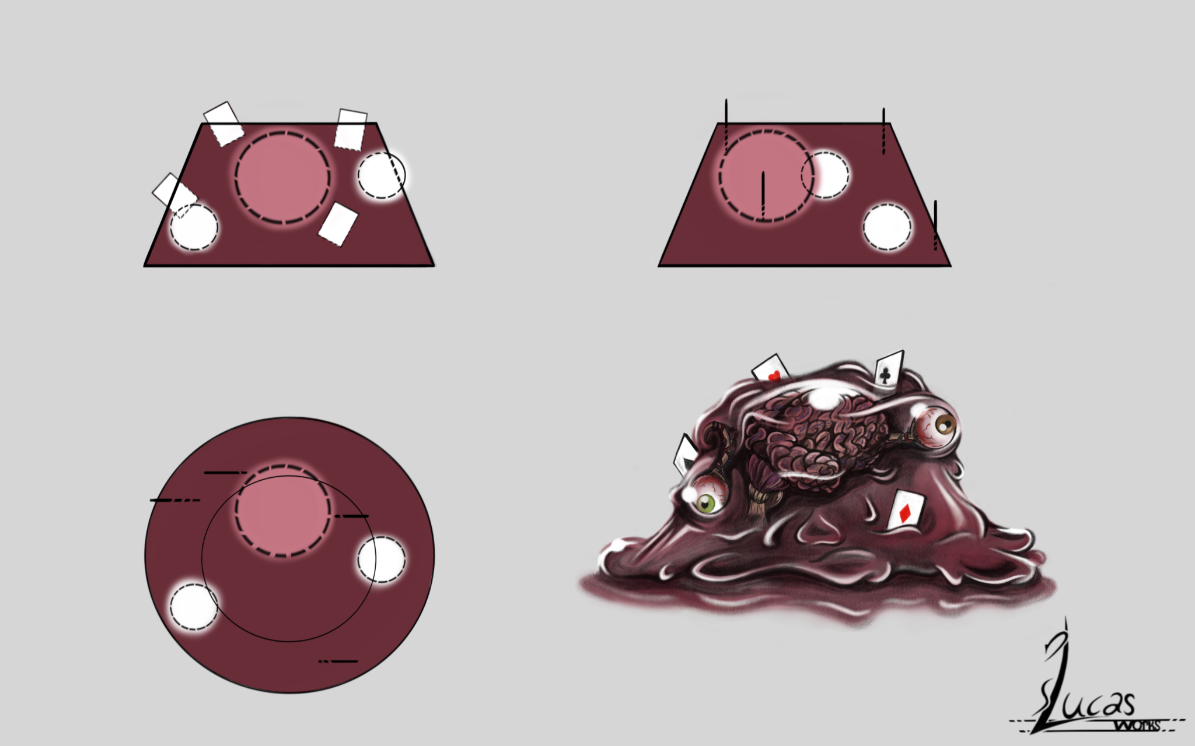

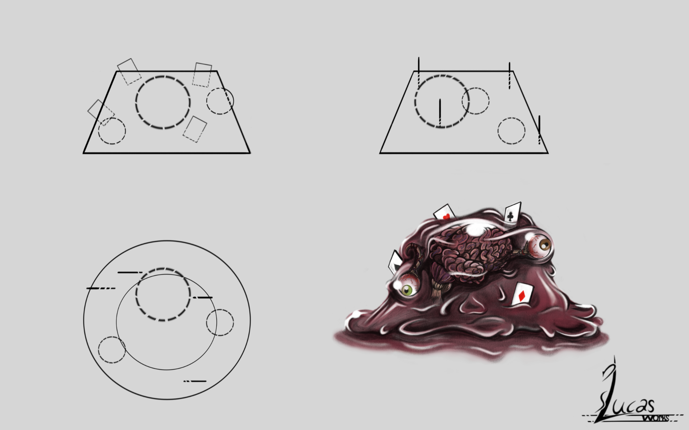

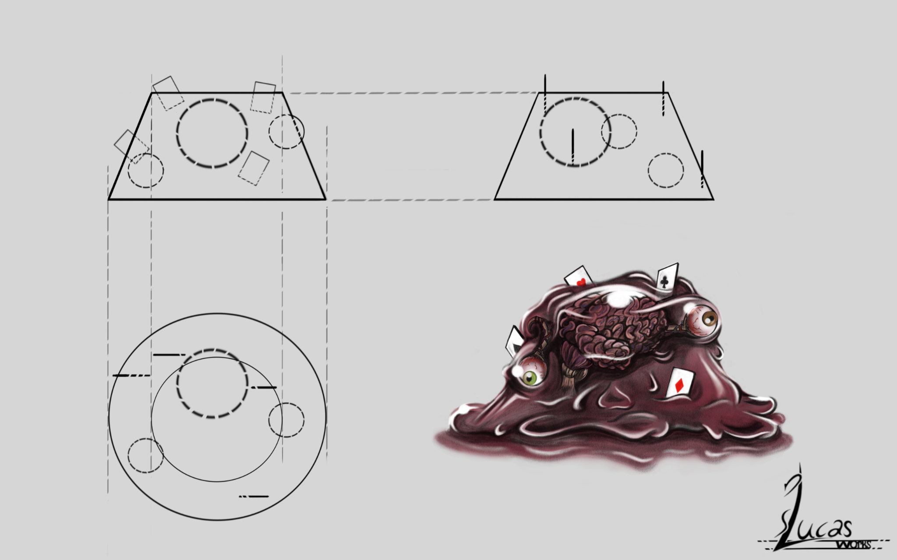

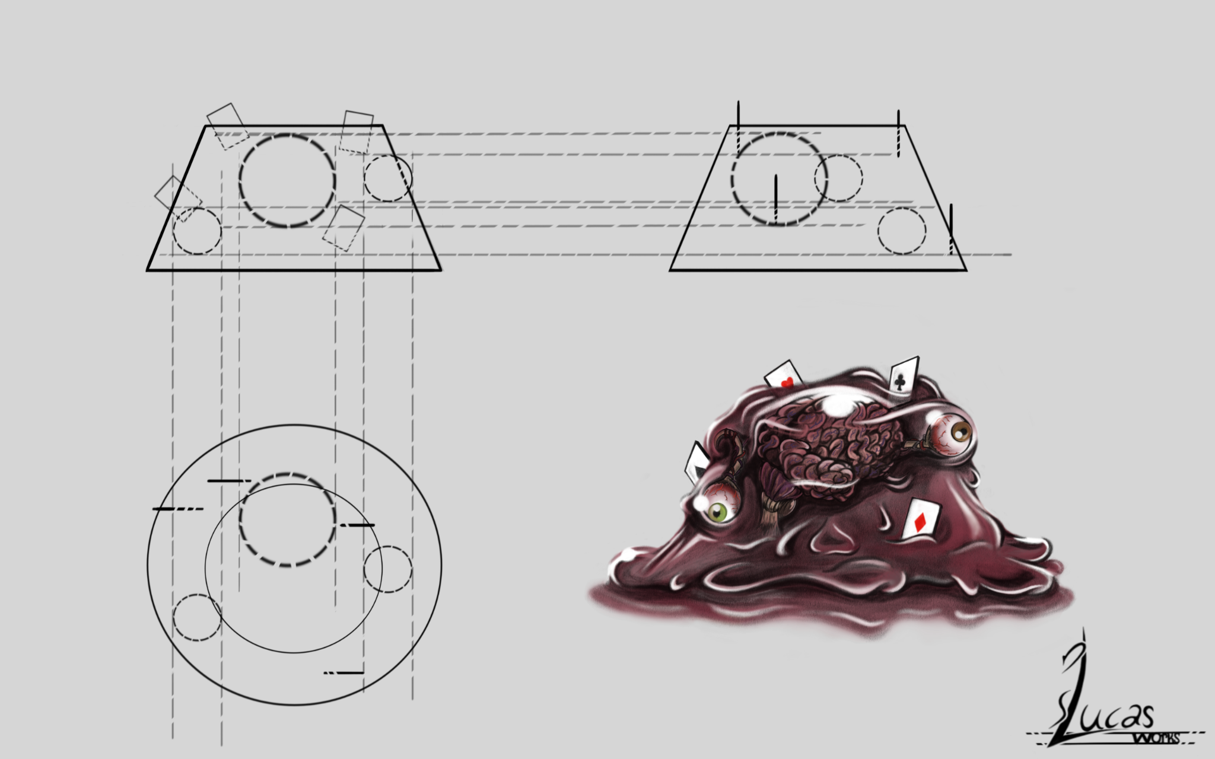

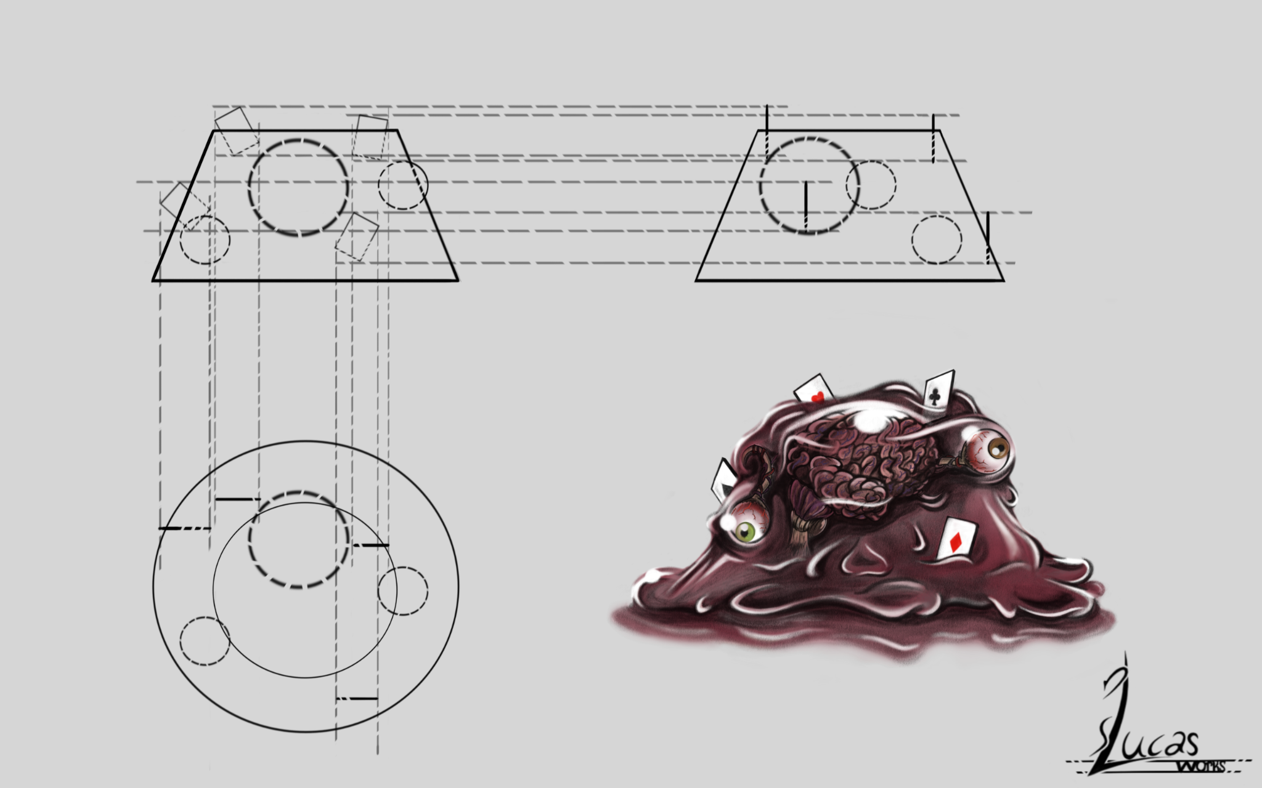

**Gameplay Character Classes**

**Gameplay Character Skills**

Start Game  
  
Player Does Whatever a player does here!!  
  
End Game  
  
[To be FILLED out BY ARTHUR]

Vision Scope  
  
Blue Prints  
  
Quick Links  
  
Photo Bucket  
  
**Mechanics**  
List all Mechanics.  
UI, Game, Player, NPC, World, Enemy, Combat,  
  
Gameplay Pillars  
Gameflow  
Key Items  
Puzzles  
Moral Stuff  
Cause Effect

Game Info

1. **Title Page**

1.1. Game Name : Name Game

1.2. Tag line :

1.3. Team : Studio

1.4. Date of last update : ??? (edited)

Game Analysis

Game Overview

Total World Consumption!

Game Concept

A game where you race against time to save a tiny town! You are the Hero!

Target Audience

Male/Females 18+

Target Platforms

Alpha On Itch.IO (free trial)

Genre

2D Action Adventure RPG

Base Game Flow Summary

Elevator Pitch?

–\ THIS IS WRONG area \ How does the player move through the game? Include both the

interface and the game itself.

Look and Feel

– What is the basic look and feel of the game? What is the visual style? (edited)

[7:03 AM]

Gameplay & Design

3. Gameplay

Main Objectives – What are the objectives of the game?

Leave the Town

Save NPCs

Defeat Enemies

Game Progression

Start off Weak, You will defeat enemies gain exp and level up, you will get stronger and defeat explore more dangerous areas.

Play Flow – How does the game flow for the game player

Mission/challenge Structure

Puzzle Structure

Mechanics & More

4. Mechanics (Key Section)

Combat Mechanics

4.1. Rules – What are the rules to the game, both implicit and explicit.

see gameplay-pillars

4.2. Model of the game universe. Think of it as a simulation of a world, how do all the pieces

interact?

4.3. Physics – How does the physical universe work?

see game-mechanics

4.4. Economy – What is the economy of the game? How does it work?

See loot-objects

4.5. Character movement in the game

See player-mechanics

4.6. Objects – how to pick them up and move them

See world-objects

See world-mechanics

4.7. Actions, including whatever switches and buttons are used, interacting with objects, and

what means of communication are used

See puzzle-ideas

See exploration

See key-items

See

4.8. Combat –

See combat-encounters

See combat-mechanics

Quick Jabs? Misses Constantly? Low Damage? Low Stamina?

Attack animation?? Shows a pause charge up. then release??

2 Second Delay?

Stomps, Kicks??

See gameplay-pillars

If there is combat or even conflict, how is this specifically modeled?

4.9. Screen Flow -- How each screen is related to every other and a description of the purpose

of each screen

4.10. Game Options - What are the options and how do they affect game play?

4.11. Replaying and saving

4.12. Cheats and Easter Eggs (edited)

Story & Lore

Story and Narrative

Back story

5.2. Plot elements

There is a legend of a boy who comes from the sky to save the world.

Are you that boy?

Game story progression

Cut scenes -- descriptions include the actors, the setting, and the storyboard or script. (edited)

[7:09 AM]

The World

6. Game World

6.1. General look and feel of world

6.2. Areas

6.2.1.General description and physical characteristics

6.2.2.How relate to the rest of the world

6.2.2.1. What levels use it

6.2.2.2. Connections to other areas (edited)

[7:09 AM]

Cast

Main Cast

The Anti-Hero Hero

The Villain

The True Boss

The Double Crosser

Secondary Cast

The rest of the 30 NPCs

Main Cast

7.1. For each character

7.1.1.Back story

7.1.2.Personality

7.1.3.Appearance

7.1.4.Abilities

7.1.5.Relevance to the story

7.1.6.Relationship to other characters

7.2. Artificial Intelligence Use in Opponent and Enemy

7.3. Non-combat and Friendly Characters (edited)

[7:10 AM]

Levels & Areas

8. Levels

8.1. Training Level

8.2. For each level

8.2.1.Synopsis

8.2.2.Required introductory material and how it is provided

8.2.3.Objectives

8.2.4.Details of what happens in the level

8.2.4.1. Map

8.2.4.2. Critical path that the player needs to take

8.2.4.3. Important and incidental encounters (edited)

[7:10 AM]

UI and More

9. Interface

9.1. Visual System

HUD

Need HP system

Inventory System

Counter for Attack

HP/ Exp GUI

Menus

Main Menu:

Pause Menu

Inventory Menu

Credits

9.1.3.Camera model

Camera follows the player, into buildings. The camera does not change, only the scale of the rooms does, in order to simulate a much larger area.

9.2. Control System – How does the game player control the game? What are the specific

Player has very limited control over the camera! (For now?)

commands? (edited)

September 1, 2022